Grid Arrangement

Definition
# Source: AI Source: Provided by: [Data Path: Persons Table -> ID Column: 1, Name_En Column: Motasem Essam] -> From: [ChatGPT] on [7/25/2026]
Grid Arrangement is a type of composite solid arrangement in which two or more repeated solid components are positioned in an organized pattern of rows and columns, forming a two-dimensional layout that extends across a plane.
The components may be identical or different in dimensions. They are distributed across a horizontal or inclined base plane and may be directly connected, partially joined, or separated by gaps.
A grid arrangement can also be extended vertically by adding multiple layers of the same grid pattern, creating a three-dimensional array of repeated components.

Simple Definition
# Source: AI Source: Provided by: [Data Path: Persons Table -> ID Column: 1, Name_En Column: Motasem Essam] -> From: [ChatGPT] on [7/25/2026]
A composite solid arrangement in which repeated solid components are organized into rows and columns, forming a grid-like pattern.

Geometric Representation
# Source: AI Source: Provided by: [Data Path: Persons Table -> ID Column: 1, Name_En Column: Motasem Essam] -> From: [ChatGPT] on [7/25/2026]
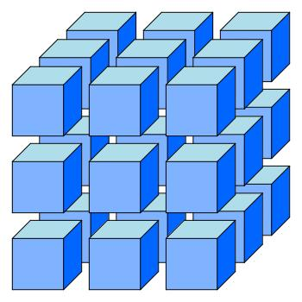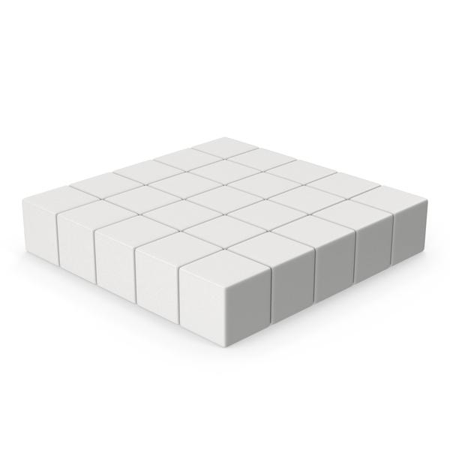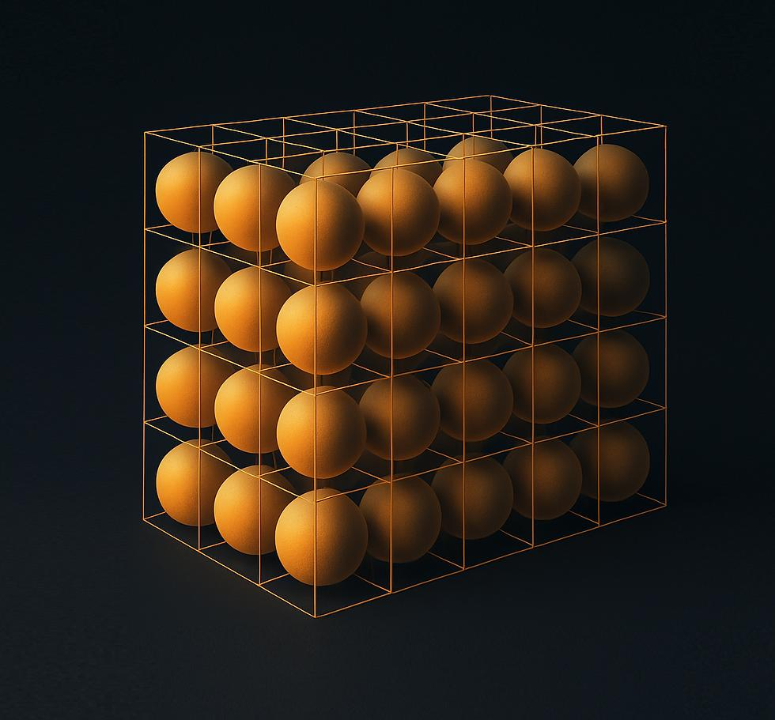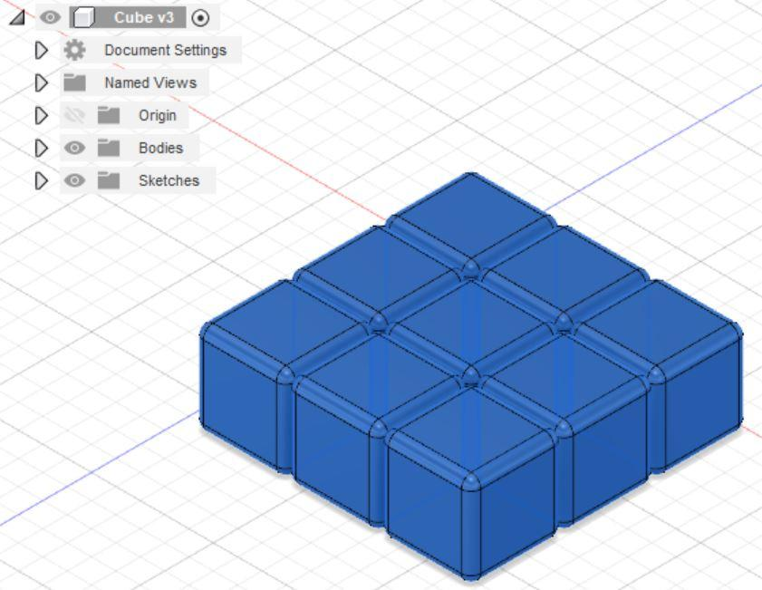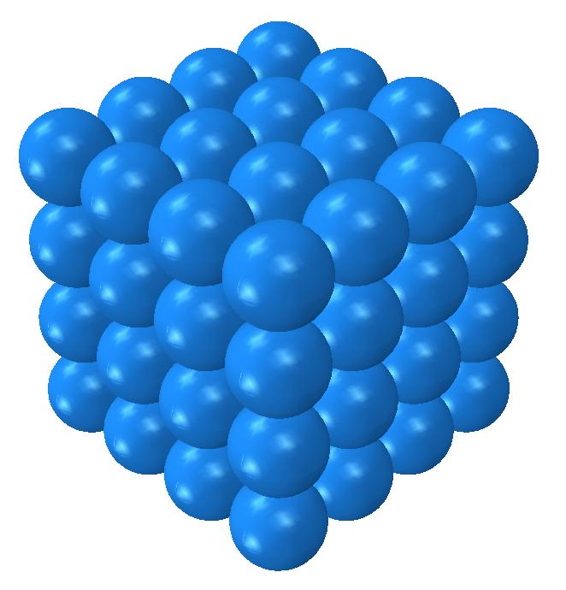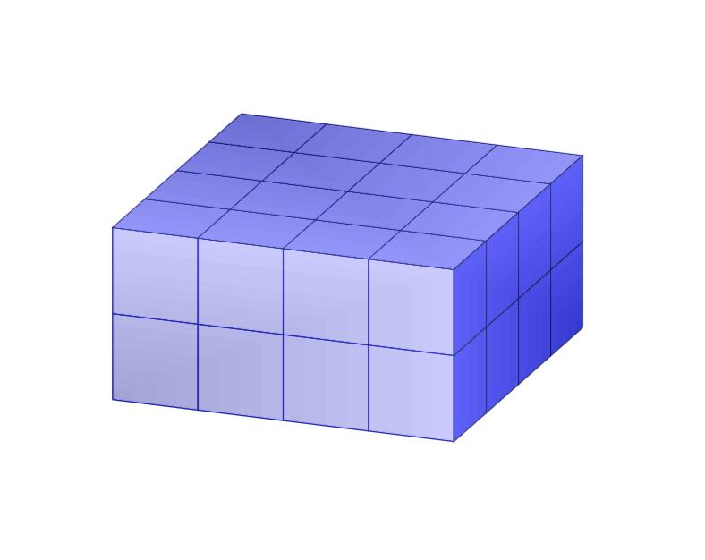
A grid arrangement has four main characteristics:
- Rows: Components are organized along one direction.
- Columns: Components are organized along a second direction.
- Regular positioning: Components follow an organized spatial pattern.
- Repeated components: The same solid type or a repeating combination of solid types is used.

Main Classification
# Source: AI Source: Provided by: [Data Path: Persons Table -> ID Column: 1, Name_En Column: Motasem Essam] -> From: [ChatGPT] on [7/25/2026]
Grid arrangements can be classified according to the geometric shape of their repeated components.

Cube-Based Grid Arrangement
# Source: AI Source: Provided by: [Data Path: Persons Table -> ID Column: 1, Name_En Column: Motasem Essam] -> From: [ChatGPT] on [7/25/2026]
A composite solid formed by positioning two or more cubes in rows and columns.
Characteristics:
- Components are cubes.
- They may have equal or different side lengths.
- Equal-sized cubes can form a larger cuboid when arranged in a complete rectangular grid.

Rectangular Prism-Based Grid Arrangement
# Source: AI Source: Provided by: [Data Path: Persons Table -> ID Column: 1, Name_En Column: Motasem Essam] -> From: [ChatGPT] on [7/25/2026]
A composite solid formed by arranging repeated rectangular prisms in an organized grid pattern.
Characteristics:
- Components have rectangular prism shapes.
- They may have identical or different dimensions.
- They can form a rectangular platform or block-like structure.

Cylinder-Based Grid Arrangement
# Source: AI Source: Provided by: [Data Path: Persons Table -> ID Column: 1, Name_En Column: Motasem Essam] -> From: [ChatGPT] on [7/25/2026]
A composite solid formed by arranging two or more cylinders in rows and columns.
Characteristics:
- Cylinders may have parallel central axes.
- They may have equal or different radii and heights.
- Their bases may rest on a common supporting plane.
- They may be arranged with regular or variable spacing.
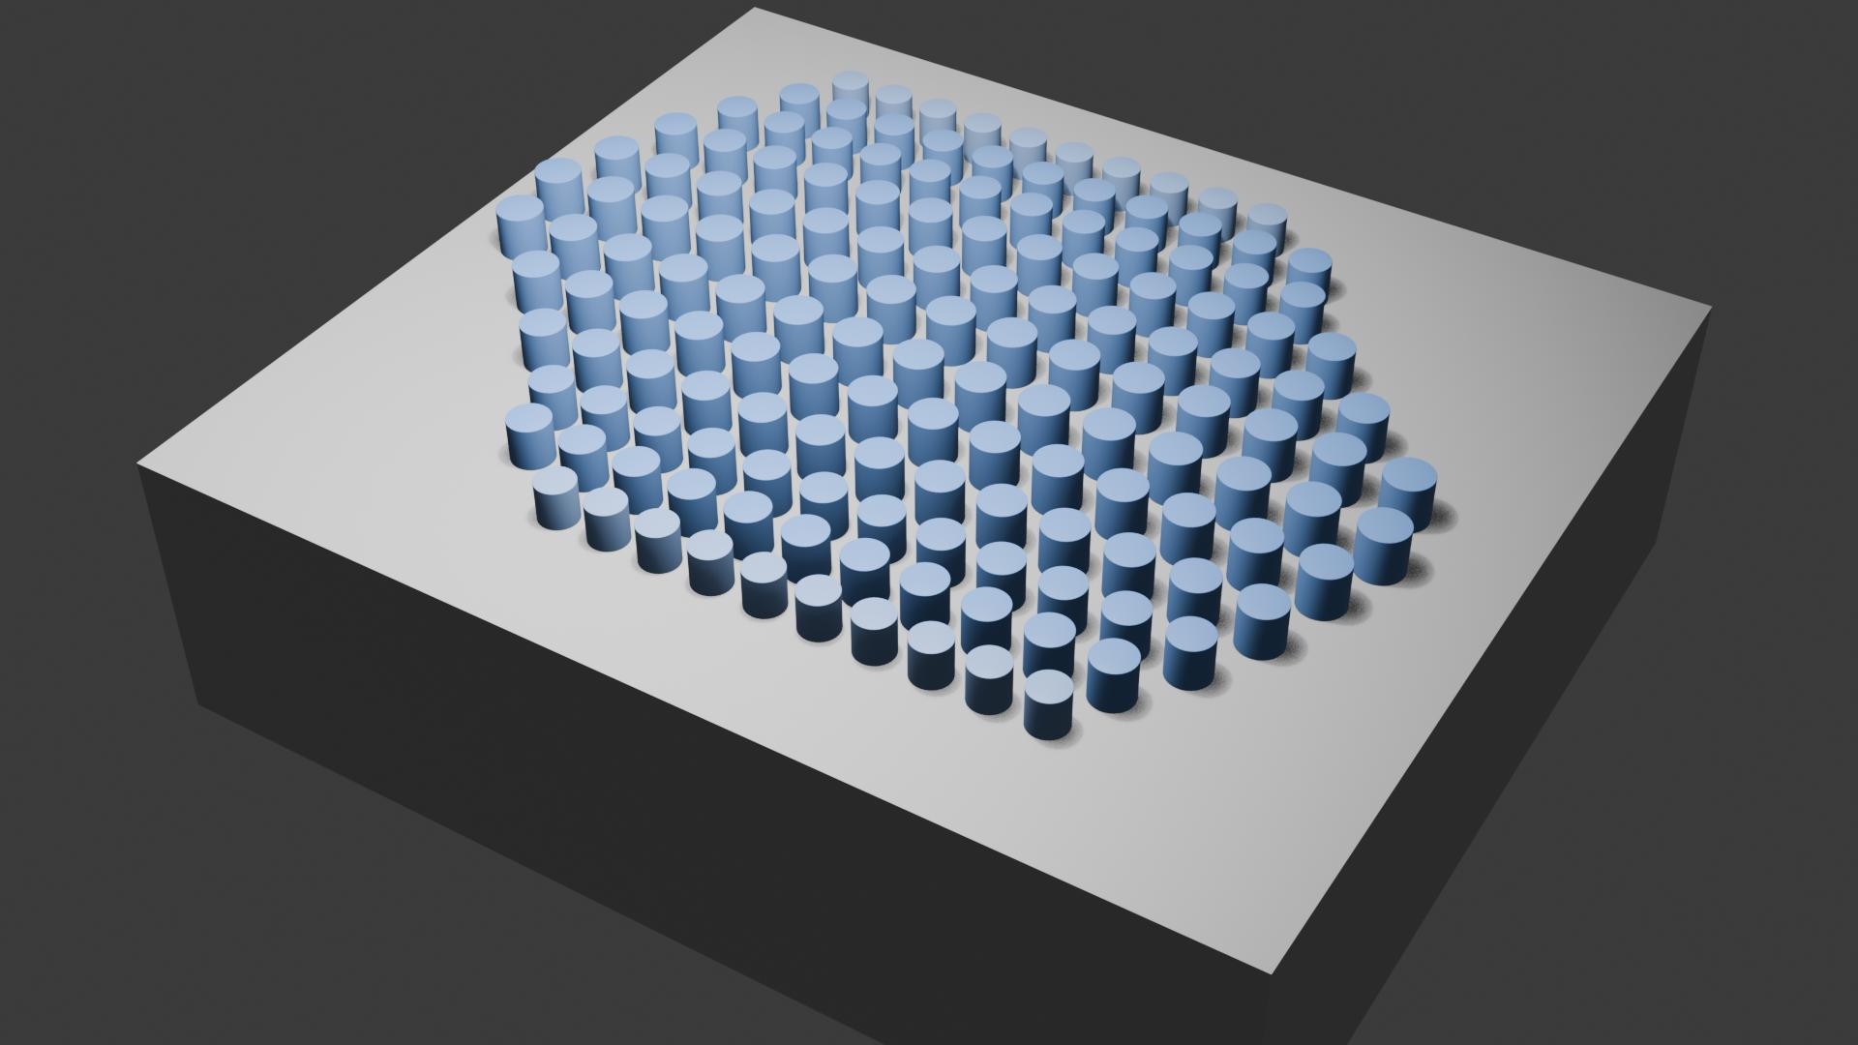

Cone-Based Grid Arrangement
# Source: AI Source: Provided by: [Data Path: Persons Table -> ID Column: 1, Name_En Column: Motasem Essam] -> From: [ChatGPT] on [7/25/2026]
A composite solid arrangement formed by positioning repeated cones in rows and columns.
Possible configurations include:
- Cones with their bases on a common horizontal plane.
- Cones arranged with their axes parallel.
- Cones with alternating orientations.
- Cones positioned on a shared supporting base.


Sphere-Based Grid Arrangement
# Source: AI Source: Provided by: [Data Path: Persons Table -> ID Column: 1, Name_En Column: Motasem Essam] -> From: [ChatGPT] on [7/25/2026]
A grid arrangement formed by positioning spheres in organized rows and columns.
Characteristics:
- Sphere centers follow a grid pattern.
- Spheres may have equal or different radii.
- They may be separated or touch neighboring spheres.
- Their centers may form a two-dimensional grid or a three-dimensional array.

Hemisphere-Based Grid Arrangement
# Source: AI Source: Provided by: [Data Path: Persons Table -> ID Column: 1, Name_En Column: Motasem Essam] -> From: [ChatGPT] on [7/25/2026]
A composite arrangement formed by positioning repeated hemispheres in rows and columns.
Possible configurations include:
- Hemispheres with their flat bases facing downward.
- Hemispherical domes arranged on a common rectangular base.
- Hemispheres arranged in multiple rows and columns.
- Alternating hemispherical orientations.
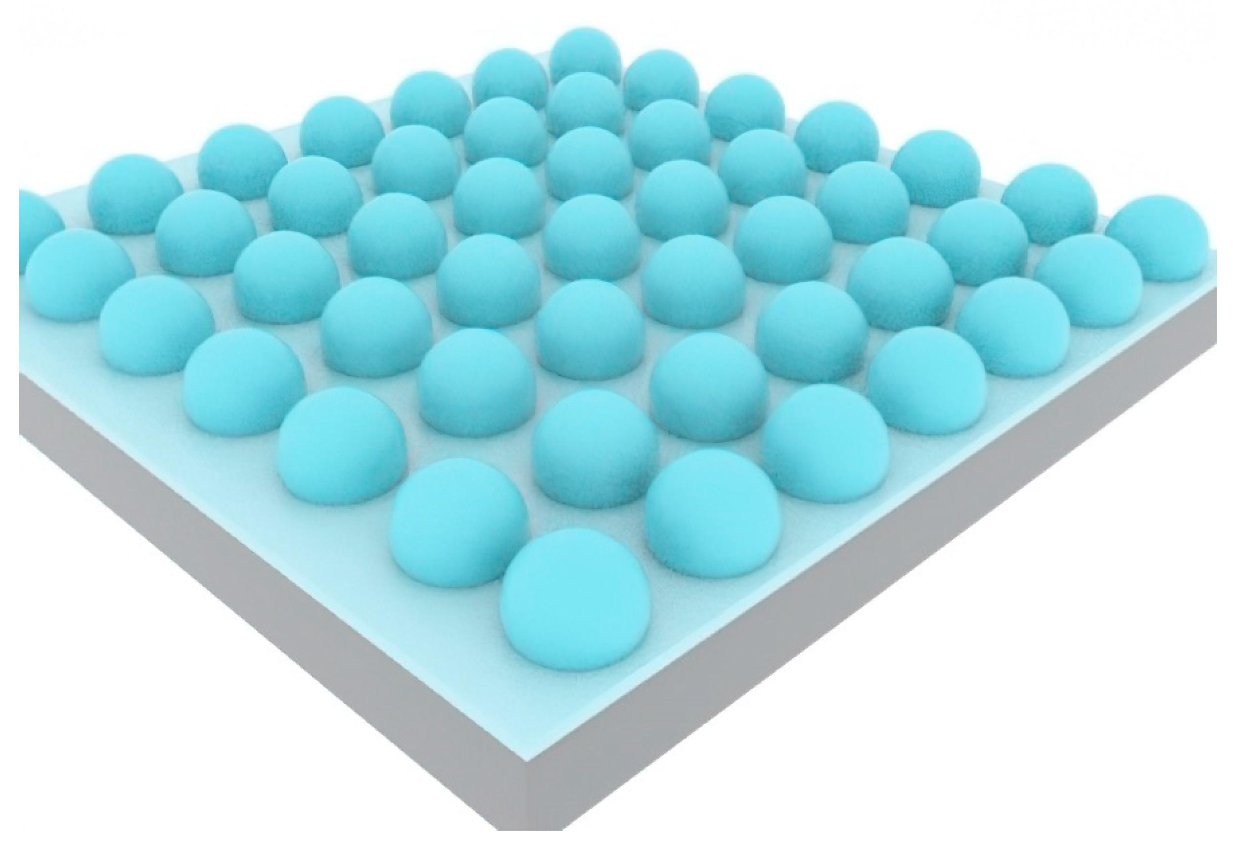

Mixed-Shape Grid Arrangement
# Source: AI Source: Provided by: [Data Path: Persons Table -> ID Column: 1, Name_En Column: Motasem Essam] -> From: [ChatGPT] on [7/25/2026]
A grid arrangement containing two or more different types of geometric solid components.
Examples:
- Alternating cubes and rectangular prisms.
- Cylinders and cones arranged in repeating positions.
- Spheres and hemispheres distributed across a grid.
- Repeated combinations of prisms, cylinders, and cones.
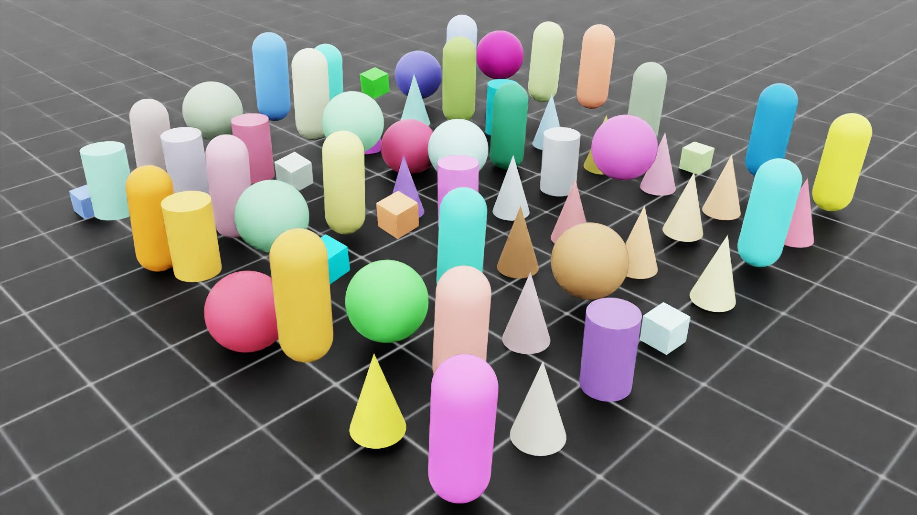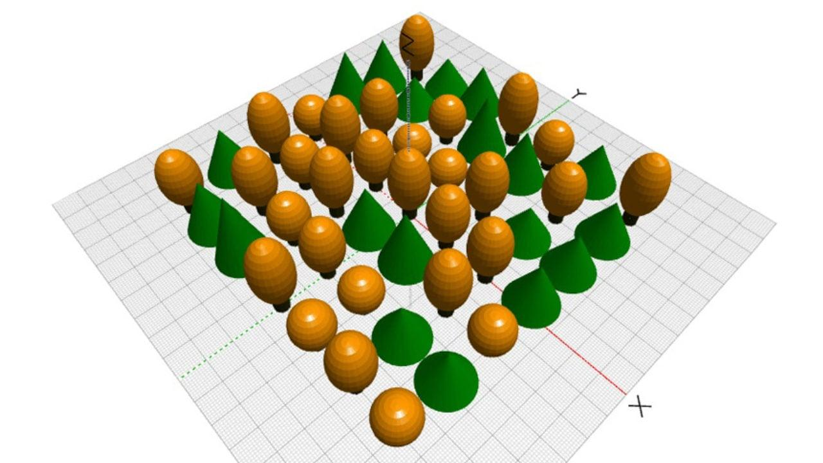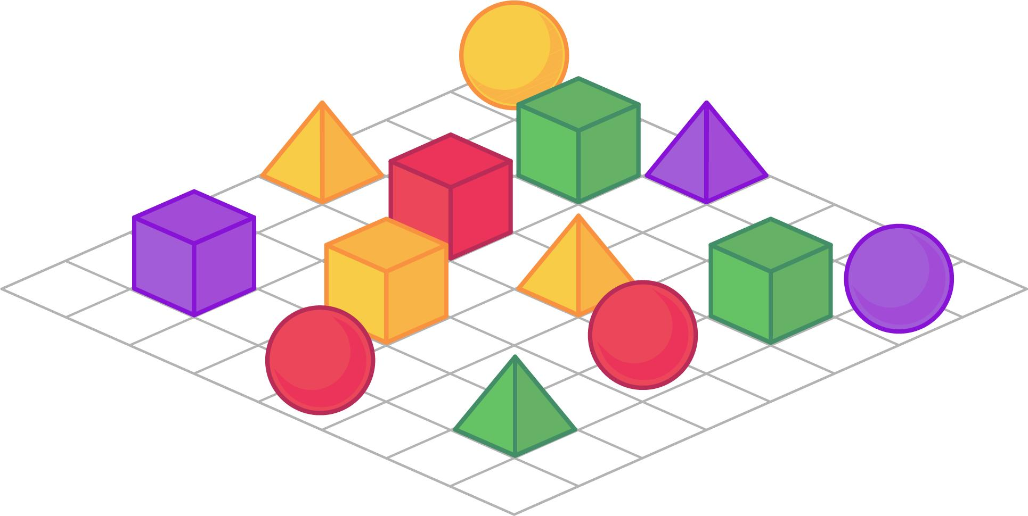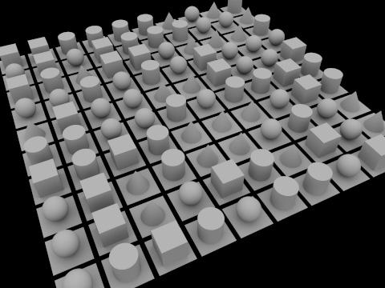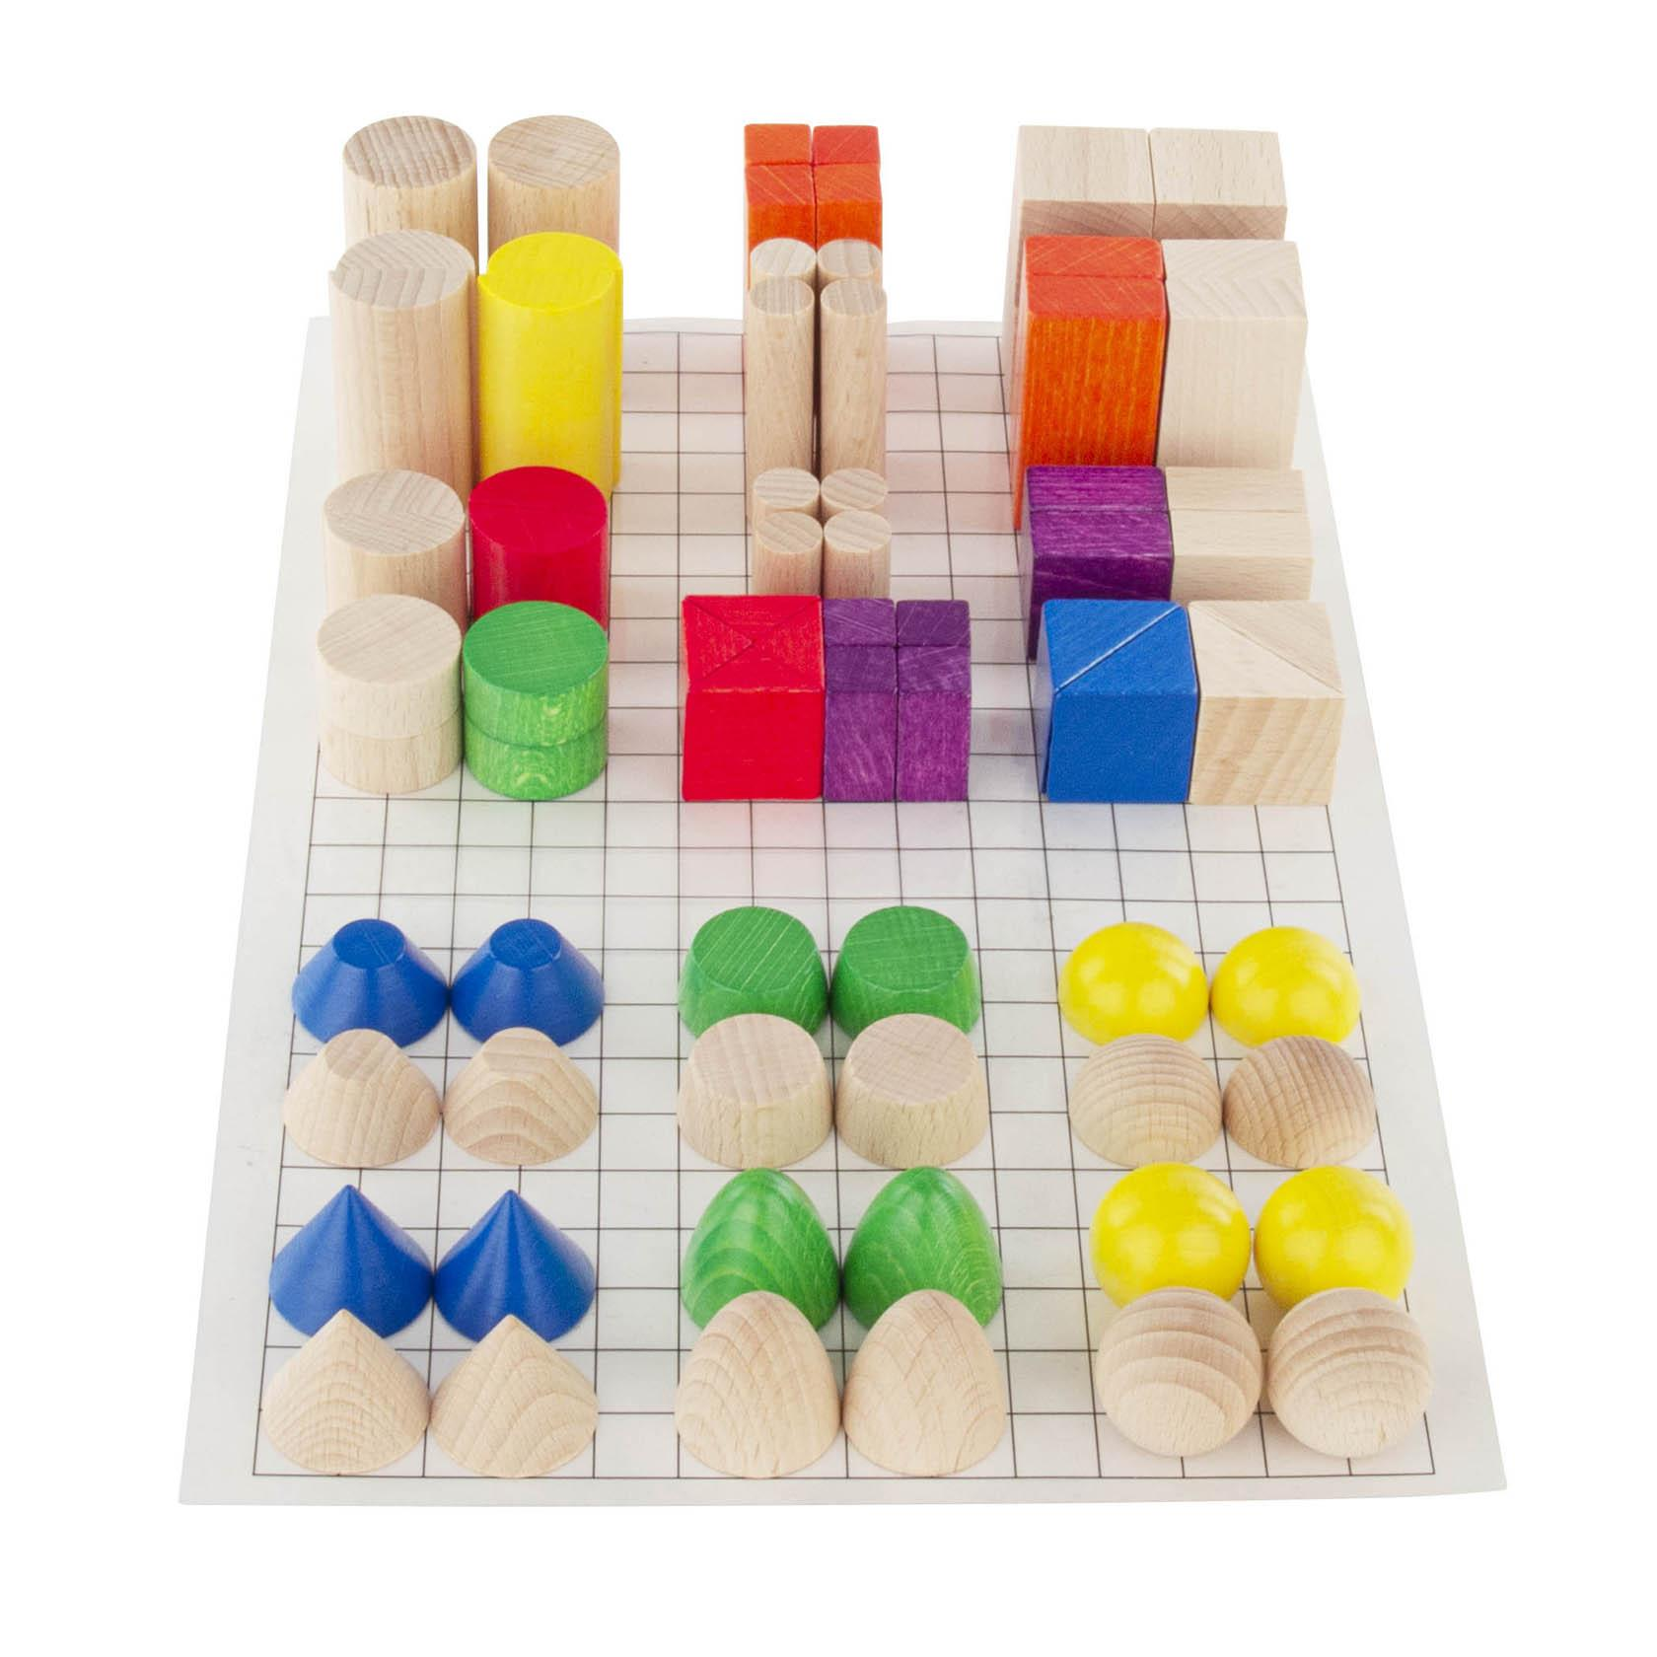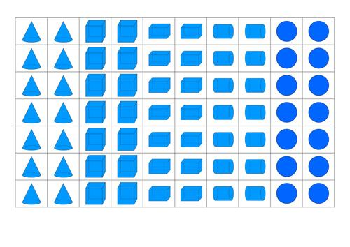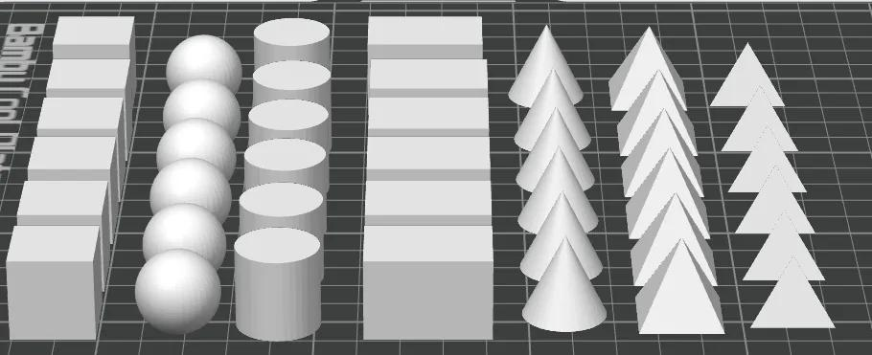

Classification by Grid Dimensions
# Source: AI Source: Provided by: [Data Path: Persons Table -> ID Column: 1, Name_En Column: Motasem Essam] -> From: [ChatGPT] on [7/25/2026]
Grid arrangements can be classified according to the number of spatial directions used to organize the components.

One-Dimensional Grid Arrangement
# Source: AI Source: Provided by: [Data Path: Persons Table -> ID Column: 1, Name_En Column: Motasem Essam] -> From: [ChatGPT] on [7/25/2026]
Components are positioned along only one direction, forming a single row or column.
Examples:
- A horizontal row of cubes.
- A vertical column of cylinders.
- A straight sequence of rectangular prisms.
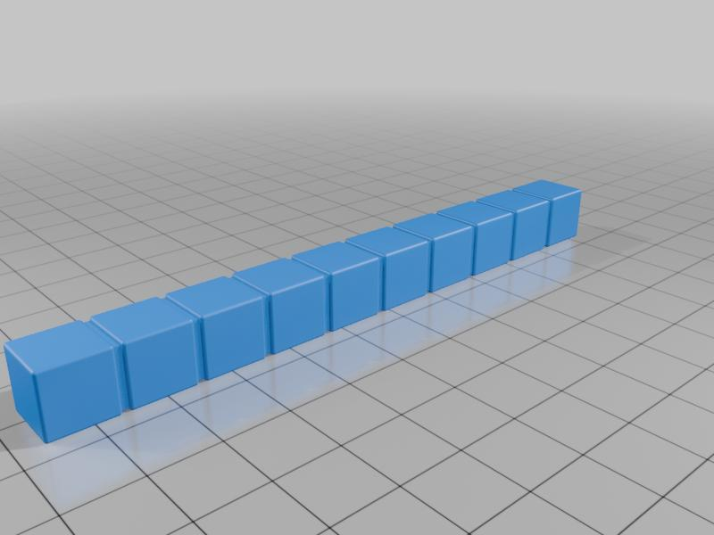

Two-Dimensional Grid Arrangement
# Source: AI Source: Provided by: [Data Path: Persons Table -> ID Column: 1, Name_En Column: Motasem Essam] -> From: [ChatGPT] on [7/25/2026]
Components are positioned along two perpendicular directions, forming rows and columns on a plane.
Examples:
- A $3×3$ arrangement of cubes.
- A $4×2$ arrangement of cylinders.
- A rectangular grid of hemispherical components.

Three-Dimensional Grid Arrangement
# Source: AI Source: Provided by: [Data Path: Persons Table -> ID Column: 1, Name_En Column: Motasem Essam] -> From: [ChatGPT] on [7/25/2026]
Components are positioned along three perpendicular spatial directions, forming rows, columns, and vertical layers.
Examples:
- A $3×3×3$ arrangement of cubes.
- A three-dimensional array of rectangular prisms.
- Cylinders arranged in multiple rows, columns, and vertical levels.
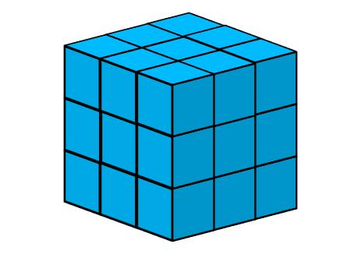

Classification by Grid Pattern

Regular Grid Arrangement
# Source: AI Source: Provided by: [Data Path: Persons Table -> ID Column: 1, Name_En Column: Motasem Essam] -> From: [ChatGPT] on [7/25/2026]
Components are positioned at equal intervals in both grid directions.
Characteristics:
- Uniform spacing.
- Repeated positioning.
- Consistent row and column alignment.
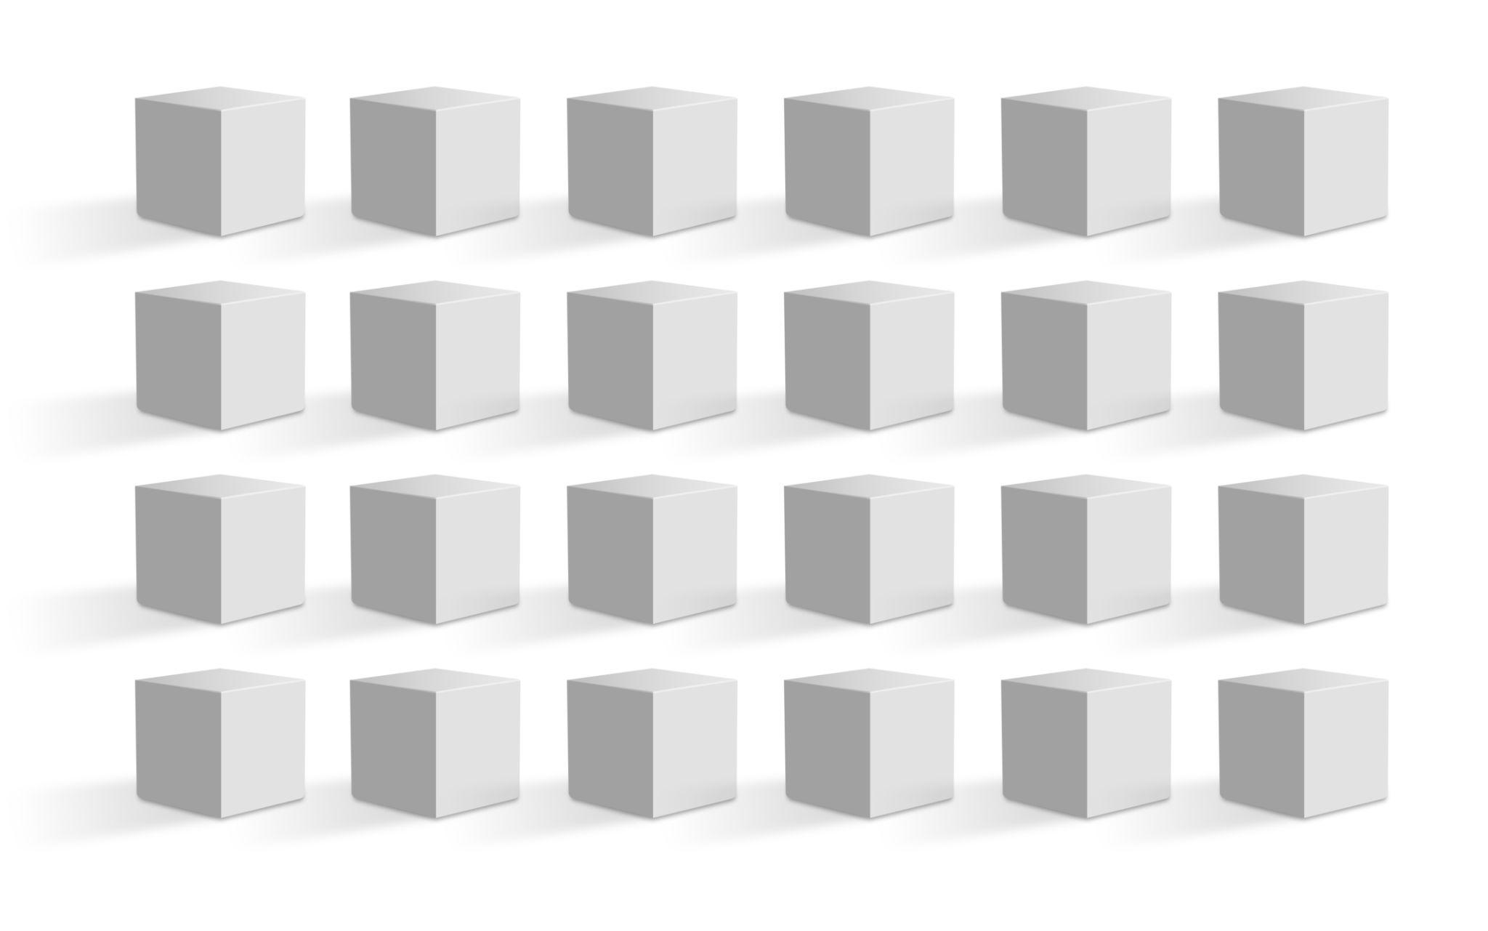

Rectangular Grid Arrangement
# Source: AI Source: Provided by: [Data Path: Persons Table -> ID Column: 1, Name_En Column: Motasem Essam] -> From: [ChatGPT] on [7/25/2026]
Components are organized into rows and columns forming a rectangular layout.
Characteristics:
- Number of rows and columns may differ.
- The overall layout has a rectangular footprint.
- Components may have equal or variable dimensions.
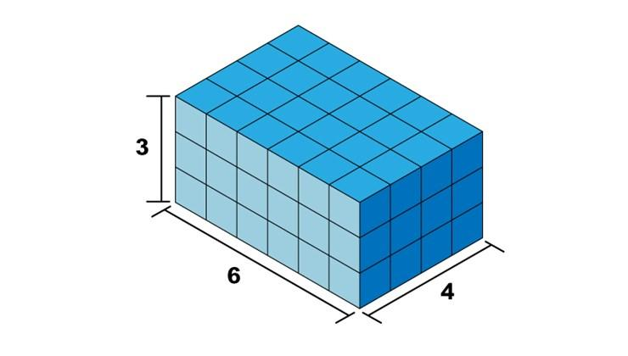

Square Grid Arrangement
# Source: AI Source: Provided by: [Data Path: Persons Table -> ID Column: 1, Name_En Column: Motasem Essam] -> From: [ChatGPT] on [7/25/2026]
Components are arranged in an equal number of rows and columns, producing a square grid layout.
Examples:
- $2×2$ grid.
- $3×3$ grid.
- $4×4$ grid.
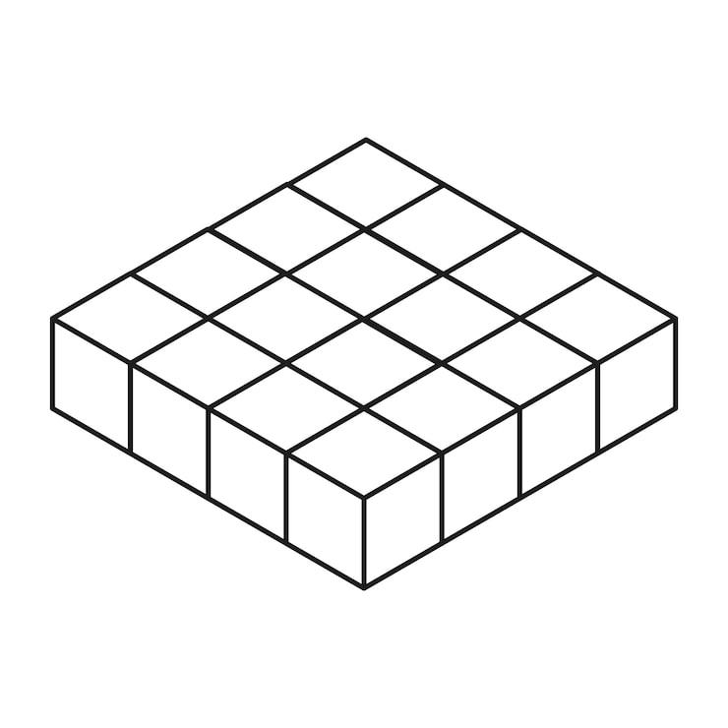

Staggered Grid Arrangement
# Source: AI Source: Provided by: [Data Path: Persons Table -> ID Column: 1, Name_En Column: Motasem Essam] -> From: [ChatGPT] on [7/25/2026]
Components are positioned in rows and columns, but alternate rows or columns are shifted relative to neighboring ones.
Examples:
- Staggered rows of cylinders.
- Offset rows of spheres.
- Alternating rows of rectangular prisms.
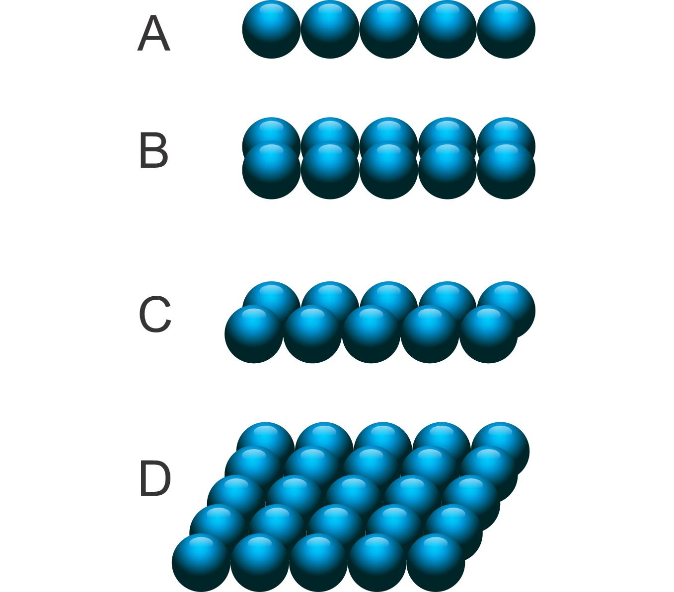

Irregular Grid Arrangement
# Source: AI Source: Provided by: [Data Path: Persons Table -> ID Column: 1, Name_En Column: Motasem Essam] -> From: [ChatGPT] on [7/25/2026]
Components are distributed according to a grid-like structure, but their spacing, dimensions, or positions are not uniform.
Examples:
- Rows with different numbers of components.
- Unequal spacing between components.
- Components of varying sizes arranged in an organized but nonuniform pattern.


Classification by Component Contact

Directly Joined Grid Arrangement
# Source: AI Source: Provided by: [Data Path: Persons Table -> ID Column: 1, Name_En Column: Motasem Essam] -> From: [ChatGPT] on [7/25/2026]
Components are connected directly to neighboring components through shared contact regions.
Examples:
- Cubes joined through their square faces.
- Rectangular prisms joined side-by-side.
- Components connected to form a larger continuous solid.
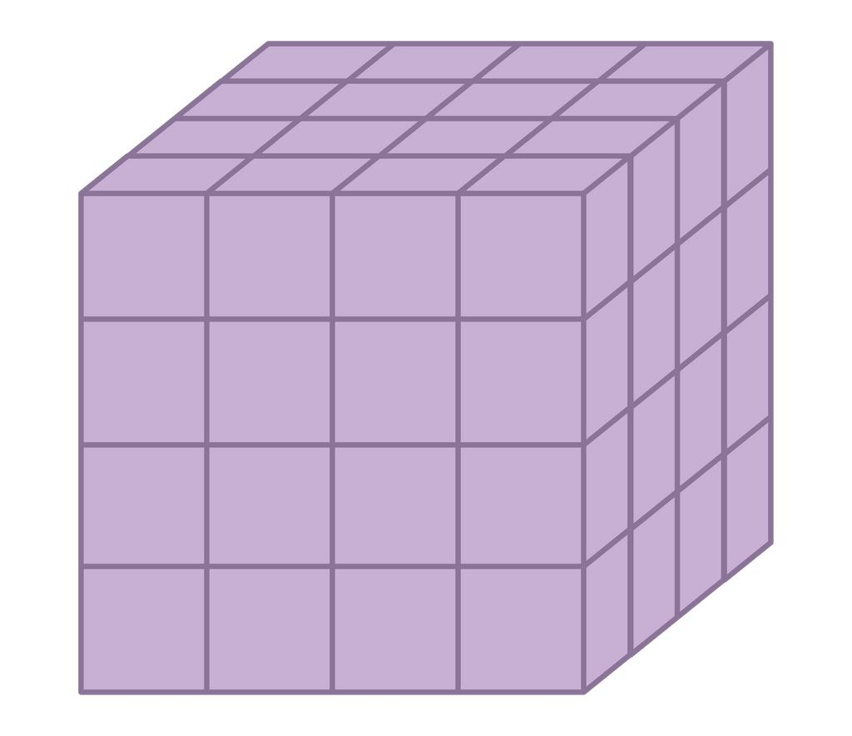

Spaced Grid Arrangement
# Source: AI Source: Provided by: [Data Path: Persons Table -> ID Column: 1, Name_En Column: Motasem Essam] -> From: [ChatGPT] on [7/25/2026]
Components are organized into rows and columns but remain separated by gaps.
Examples:
- Spheres arranged in a regular grid with spaces.
- Cylinders distributed across a rectangular platform.
- Repeated cubes with equal spacing.
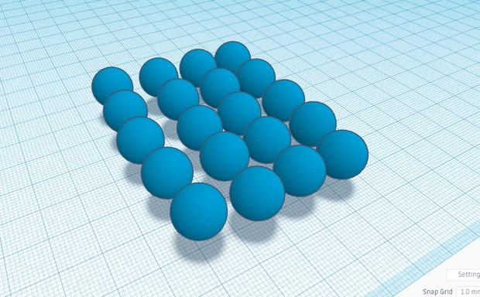

Partially Joined Grid Arrangement
# Source: AI Source: Provided by: [Data Path: Persons Table -> ID Column: 1, Name_En Column: Motasem Essam] -> From: [ChatGPT] on [7/25/2026]
Components are connected through only part of their possible contact regions.
Examples:
- Cylinders touching neighboring cylinders along curved regions.
- Smaller blocks attached to larger block faces.
- Components partially supported by neighboring components.
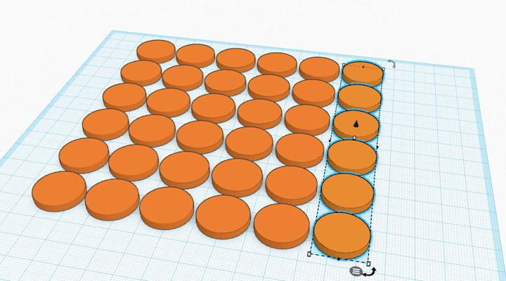

Classification by Component Dimensions
# Source: AI Source: Provided by: [Data Path: Persons Table -> ID Column: 1, Name_En Column: Motasem Essam] -> From: [ChatGPT] on [7/25/2026]
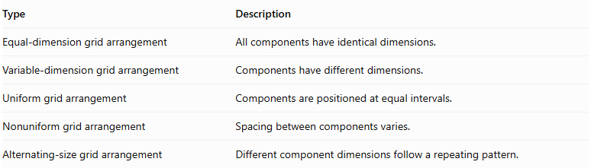
Type | Description
Equal-dimension grid arrangement | All components have identical dimensions.
Variable-dimension grid arrangement | Components have different dimensions.
Uniform grid arrangement | Components are positioned at equal intervals.
Nonuniform grid arrangement | Spacing between components varies.
Alternating-size grid arrangement | Different component dimensions follow a repeating pattern.

Mathematical Properties and Formulas

Total Number of Components
# Source: AI Source: Provided by: [Data Path: Persons Table -> ID Column: 1, Name_En Column: Motasem Essam] -> From: [ChatGPT] on [7/25/2026]
For a two-dimensional rectangular grid:
$$\boxed{N=R×C}$$
For a three-dimensional grid:
$$\boxed{N=R×C×L}$$
Where:
- $R$ = number of rows.
- $C$ = number of columns.
- $L$ = number of vertical layers.

Total Volume
# Source: AI Source: Provided by: [Data Path: Persons Table -> ID Column: 1, Name_En Column: Motasem Essam] -> From: [ChatGPT] on [7/25/2026]
For components arranged without overlapping interiors:
$$V_{total}=\sum_{i=1}^{N}{V_{i}}$$
For identical components:
$$\boxed{V_{total}={NV}_{component}}$$
Common volume formulas:
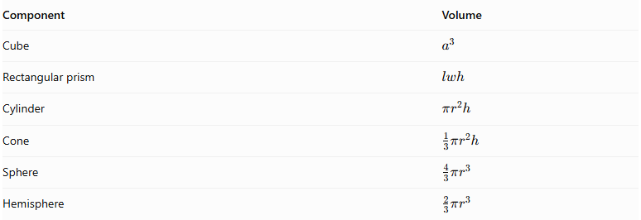
Component | Volume
Cube | $$a^{3}$$
Rectangular prism | $$lwh$$
Cylinder | $$πr^{2}h$$
Cone | $$\frac{1}{3}πr^{2}h$$
Sphere | $$\frac{4}{3}πr^{3}$$
Hemisphere | $$\frac{2}{3}πr^{3}$$

Overall Dimensions
# Source: AI Source: Provided by: [Data Path: Persons Table -> ID Column: 1, Name_En Column: Motasem Essam] -> From: [ChatGPT] on [7/25/2026]
For identical rectangular components arranged in a regular grid without gaps:
$$\boxed{L_{total}=Cl}$$
$$\boxed{W_{total}=Rw}$$
For a three-dimensional grid:
$$\boxed{H_{total}=Lh}$$
Where:
- $l$ = component length.
- $w$ = component width.
- $h$ = component height.
If equal gaps are present:
$$L_{total}=Cl+(C-1)g_{x}$$
$$W_{total}=Rw+(R-1)g_{y}$$
For a three-dimensional grid, vertical gaps can also be included:
$$H_{total}=Lh+(L-1)g_{z}$$

External Surface Area
# Source: AI Source: Provided by: [Data Path: Persons Table -> ID Column: 1, Name_En Column: Motasem Essam] -> From: [ChatGPT] on [7/25/2026]
For directly joined components:
$${SA}_{external}=\sum{{SA}_{individual}}-\sum{A_{hidden interfaces}}$$
For complete matching planar joining faces:
$$\boxed{{SA}_{external}=\sum{{SA}_{individual}}-2\sum{A_{joining}}}$$
For spaced components, the individual surface areas are added without subtracting joining regions.
For partial or curved contacts, calculate the actual exposed and hidden surface regions.

Worked Examples

Example 1: Two-Dimensional Grid of Identical Cubes
# Source: AI Source: Provided by: [Data Path: Persons Table -> ID Column: 1, Name_En Column: Motasem Essam] -> From: [ChatGPT] on [7/25/2026]
A grid contains $3$ rows and $4$ columns of identical cubes. Each cube has a side length of $3 cm$. All cubes are directly joined face-to-face.
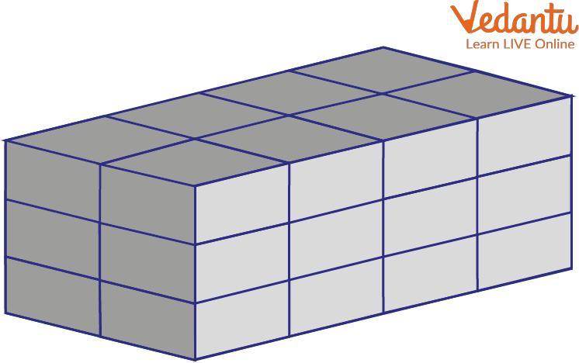
Step 1: Calculate the number of cubes.
$$N=R×C$$
$$N=3×4$$
$$\boxed{N=12}$$
Step 2: Calculate the volume of one cube.
$$V_{1}=a^{3}$$
$$V_{1}=3^{3}=27{ cm}^{3}$$
Step 3: Calculate the total volume.
$$V_{total}=12×27$$
$$\boxed{V_{total}=324{ cm}^{3}}$$
Step 4: Calculate the overall dimensions.
$$L=4×3=12 cm$$
$$W=3×3=9 cm$$
$$H=3 cm$$
Step 5: Calculate the external surface area.
The resulting solid is a rectangular prism:
$$12×9×3$$
$$SA=2(lw+lh+wh)$$
$$=2(12×9+12×3+9×3)$$
$$=2(108+36+27)$$
$$\boxed{SA=342{ cm}^{2}}$$

Example 2: Three-Dimensional Grid of Identical Cubes
# Source: AI Source: Provided by: [Data Path: Persons Table -> ID Column: 1, Name_En Column: Motasem Essam] -> From: [ChatGPT] on [7/25/2026]
A three-dimensional grid contains $2$ rows, $3$ columns, and $2$ vertical layers of identical cubes. Each cube has a side length of $4 cm$. All cubes are joined face-to-face.
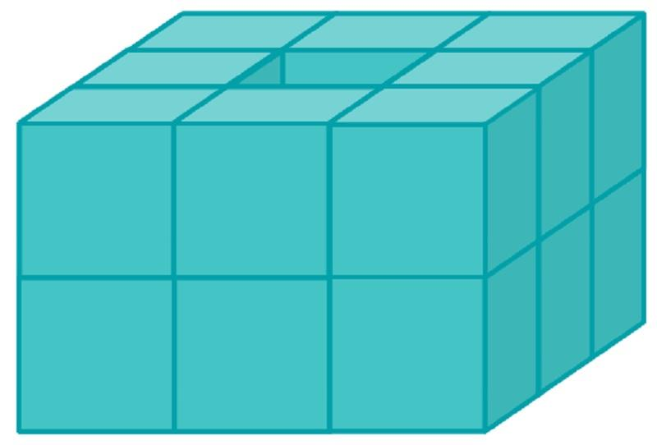
Step 1: Calculate the total number of cubes.
$$N=R×C×L$$
$$N=2×3×2$$
$$\boxed{N=12}$$
Step 2: Calculate the volume of one cube.
$$V_{1}=4^{3}=64{ cm}^{3}$$
Step 3: Calculate the total volume.
$$V_{total}=12×64$$
$$\boxed{V_{total}=768{ cm}^{3}}$$
Step 4: Calculate the overall dimensions.
$$L=3×4=12 cm$$
$$W=2×4=8 cm$$
$$H=2×4=8 cm$$
Step 5: Calculate the external surface area.
The resulting solid is a rectangular prism:
$$12×8×8$$
$$SA=2(lw+lh+wh)$$
$$=2(12×8+12×8+8×8)$$
$$=2(96+96+64)$$
$$\boxed{SA=512{ cm}^{2}}$$

Important Characteristics
# Source: AI Source: Provided by: [Data Path: Persons Table -> ID Column: 1, Name_En Column: Motasem Essam] -> From: [ChatGPT] on [7/25/2026]
- Grid-based positioning: Components are organized into rows and columns.
- Multiple directions: Components extend across two or three spatial directions.
- Repeated components: The arrangement uses identical or repeating solid types.
- Regular or irregular spacing: Components may be uniformly or nonuniformly distributed.
- Variable dimensions: Components may have equal or different dimensions.
- Multiple layers: A two-dimensional grid can be extended vertically into a three-dimensional array.
- Flexible contact: Components may be joined, partially joined, or separated by gaps.
- Predictable component count: The number of components can be calculated using rows, columns, and layers.

Comparison with Other Component Arrangements
# Source: AI Source: Provided by: [Data Path: Persons Table -> ID Column: 1, Name_En Column: Motasem Essam] -> From: [ChatGPT] on [7/25/2026]
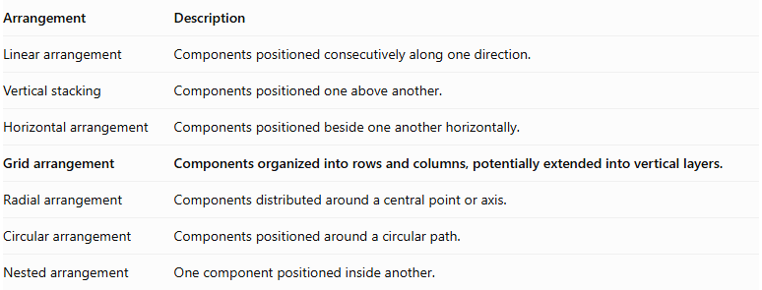
Arrangement | Description
Linear arrangement | Components positioned consecutively along one direction.
Vertical stacking | Components positioned one above another.
Horizontal arrangement | Components positioned beside one another horizontally.
Grid arrangement | Components organized into rows and columns, potentially extended into vertical layers.
Radial arrangement | Components distributed around a central point or axis.
Circular arrangement | Components positioned around a circular path.
Nested arrangement | One component positioned inside another.

Applications
# Source: AI Source: Provided by: [Data Path: Persons Table -> ID Column: 1, Name_En Column: Motasem Essam] -> From: [ChatGPT] on [7/25/2026]
- Building blocks and modular construction systems.
- Storage systems and shelving structures.
- Arrays of industrial components.
- Solar panel and equipment arrangements.
- Geometric models and educational constructions.
- Three-dimensional structural frameworks.
- Repeated mechanical and architectural components.

Key Points
# Source: AI Source: Provided by: [Data Path: Persons Table -> ID Column: 1, Name_En Column: Motasem Essam] -> From: [ChatGPT] on [7/25/2026]
- Grid arrangement organizes repeated solid components into rows and columns.
- It may be one-dimensional, two-dimensional, or three-dimensional.
- Grid patterns may be regular, rectangular, square, staggered, or irregular.
- Components may be cubes, rectangular prisms, cylinders, cones, spheres, hemispheres, or mixed shapes.
- The number of components is calculated using rows, columns, and layers.
- Total volume is the sum of component volumes when there is no overlap.
- External surface area excludes hidden joining regions.

Conclusion
# Source: AI Source: Provided by: [Data Path: Persons Table -> ID Column: 1, Name_En Column: Motasem Essam] -> From: [ChatGPT] on [7/25/2026]
Grid Arrangement is a classification of composite solids in which repeated components are organized into rows and columns. It can form a two-dimensional layout or a three-dimensional array when additional vertical layers are introduced. Its geometry depends on the number of rows, columns, and layers, as well as component dimensions, spacing, alignment, and contact regions.

